GCP-VERTEX AI

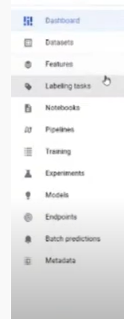

Dataset:

Managed dataset

Types of managed datasets



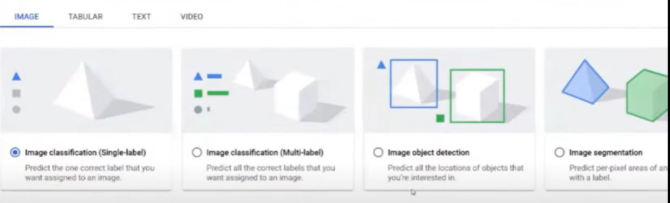

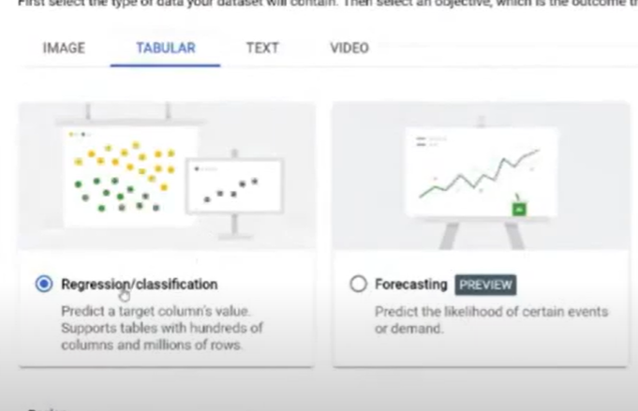

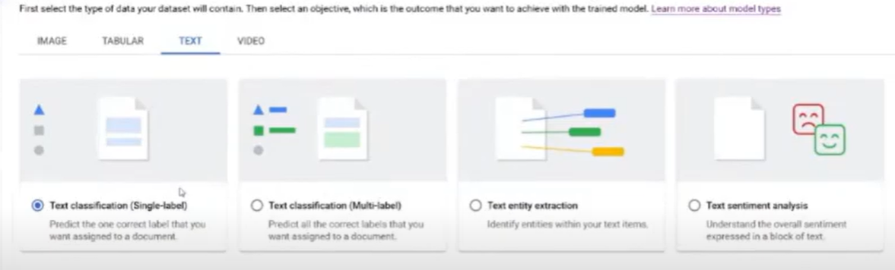

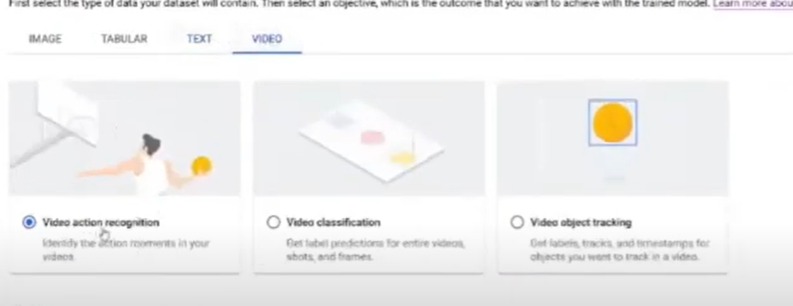

Dataset location

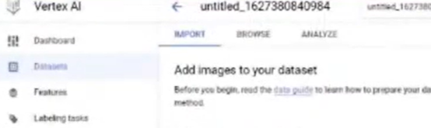

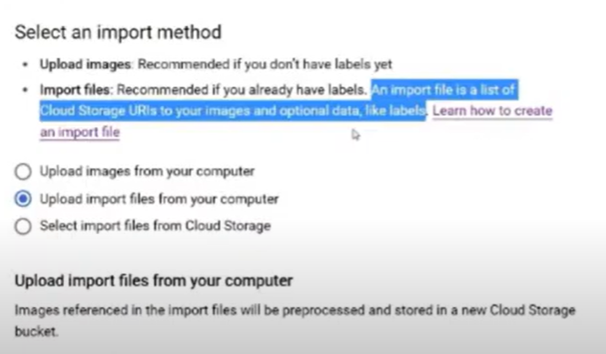

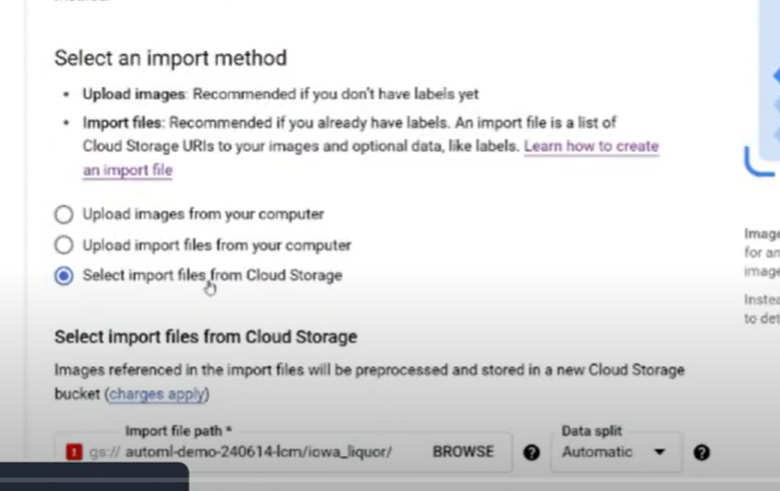

Labelling task:

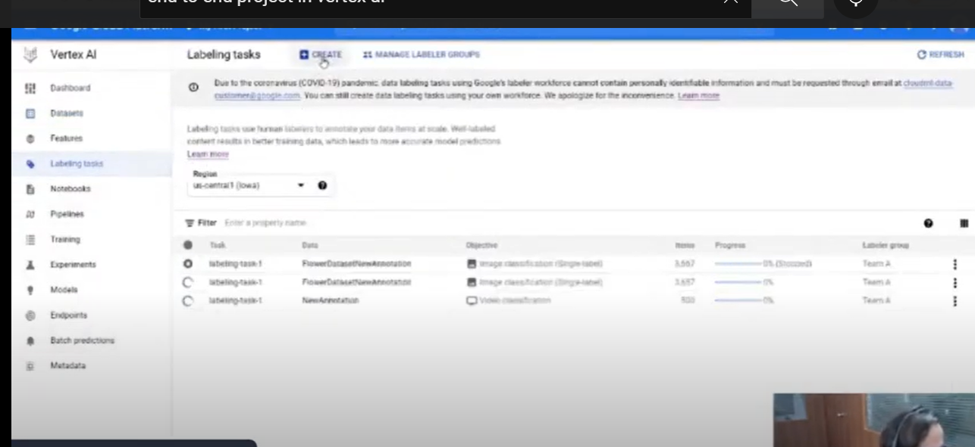

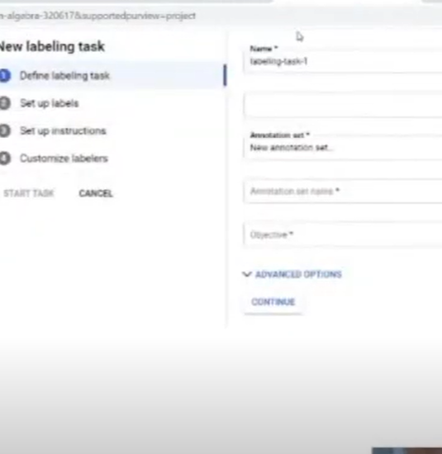

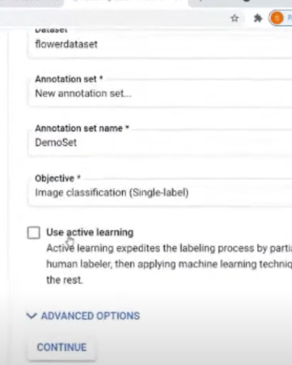

If u click on active learning if u label few google will label other images

Otherwise, specific team should be allotted to do that

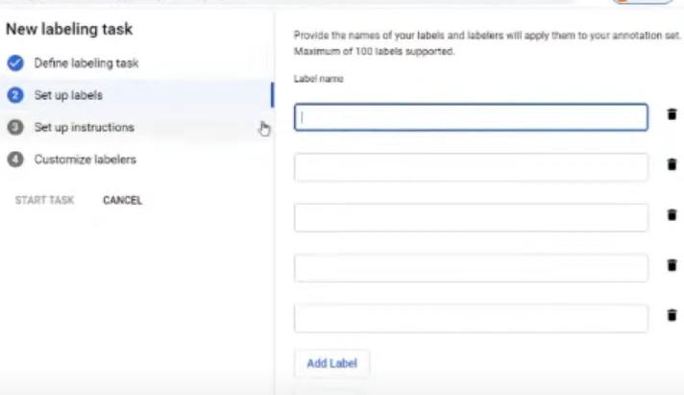

Different labels which u have to give

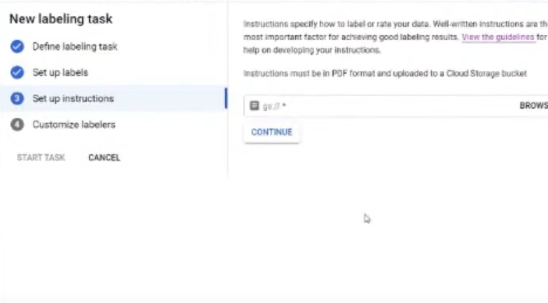

Specify instruction to team

Select browse – bucket where u have saved instruction

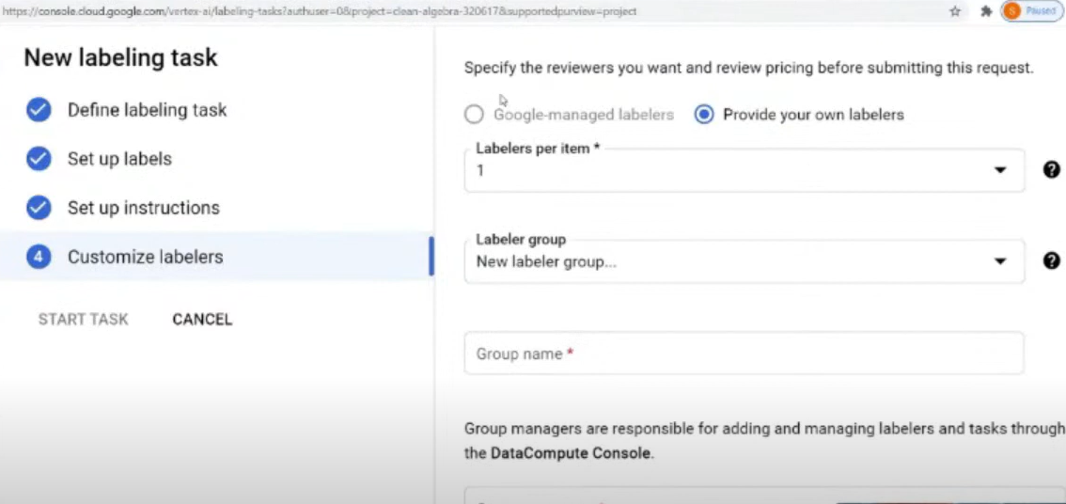

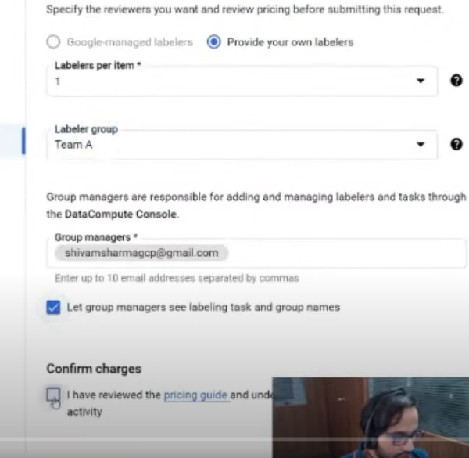

To label dataset

Goto dataset> open dataset which u have to label

Go annot option and label

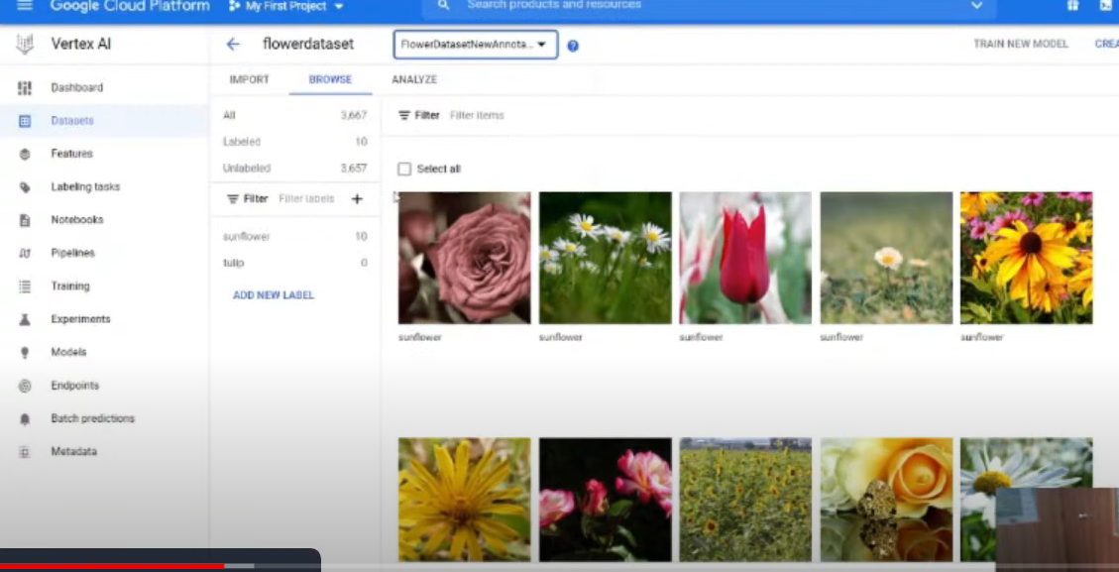

If u have managed dataset u can do both custom and auto ML  
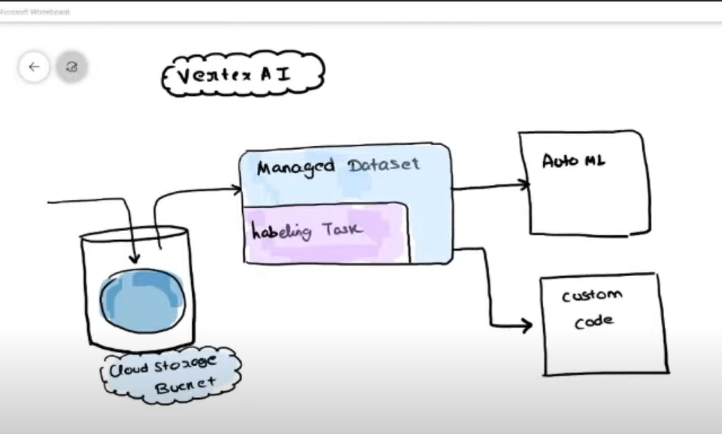

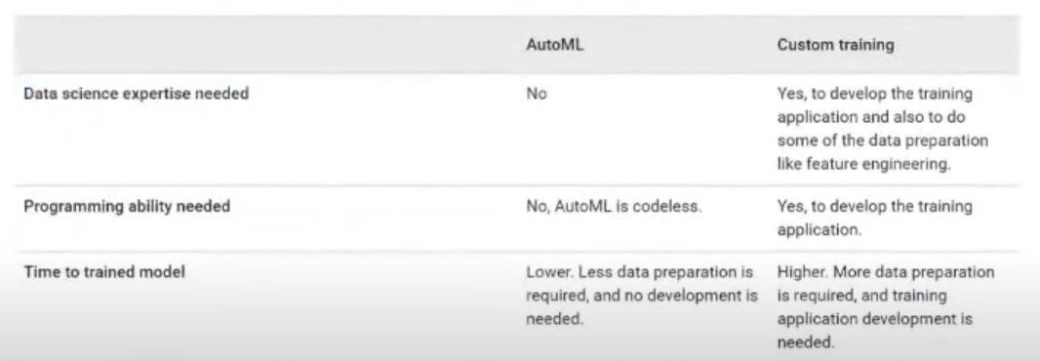

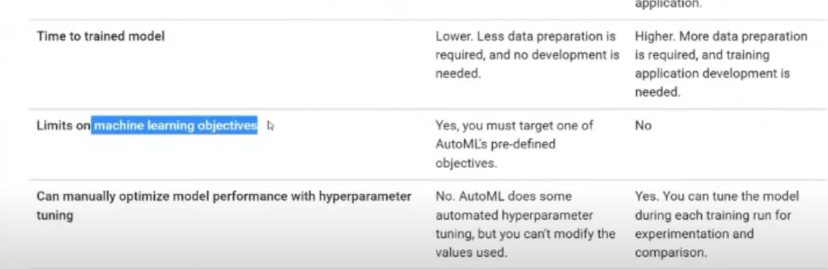

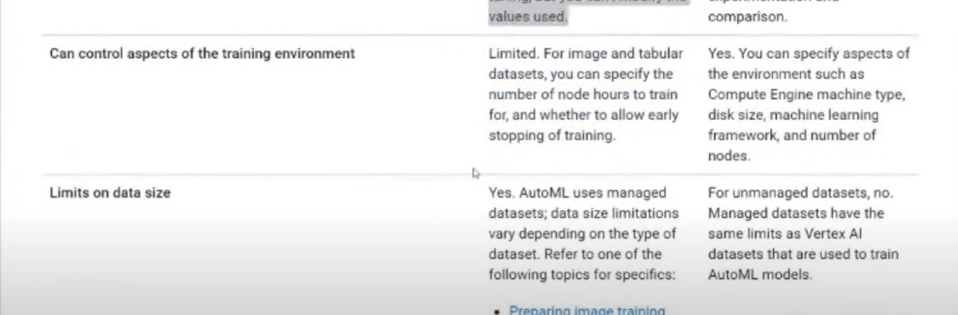

Training

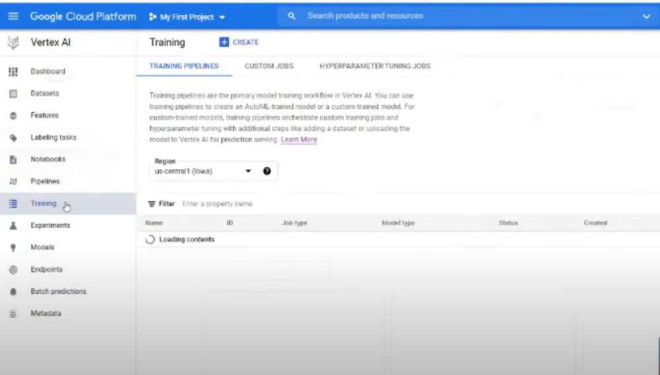

How to train

Create:

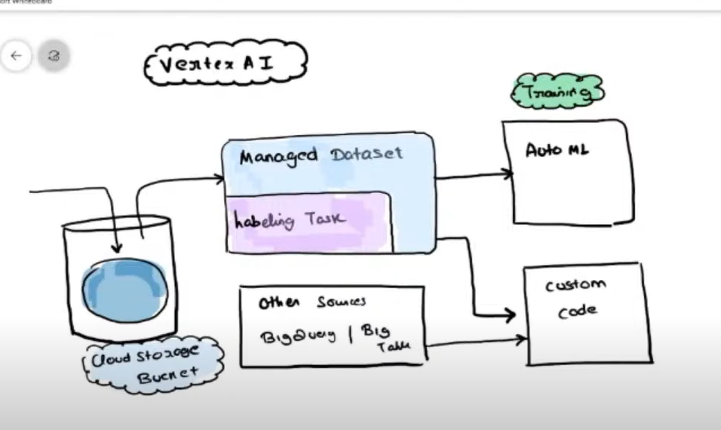

No managed dataset

Then custom training

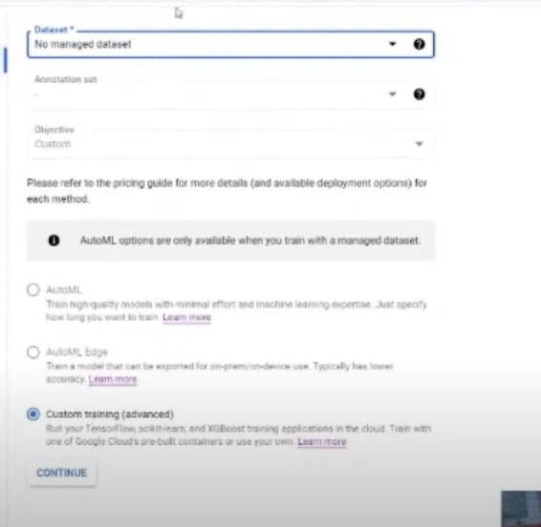

Automl

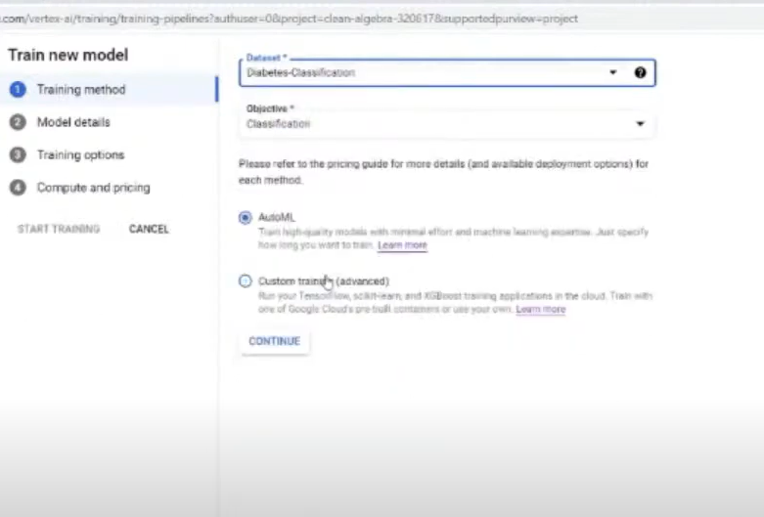

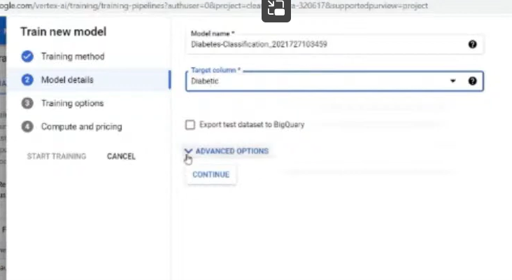

Advanced settings(optional)

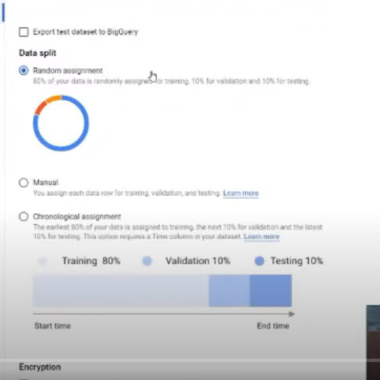

Train test

Encryption

Transformations(encoding)

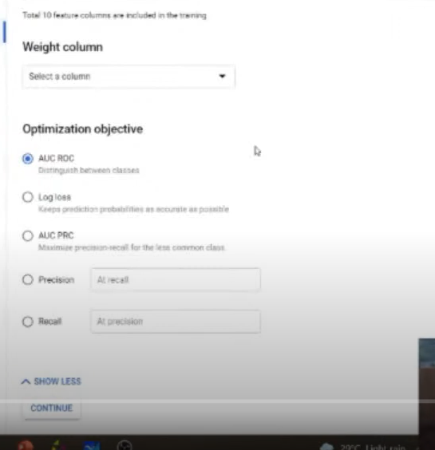

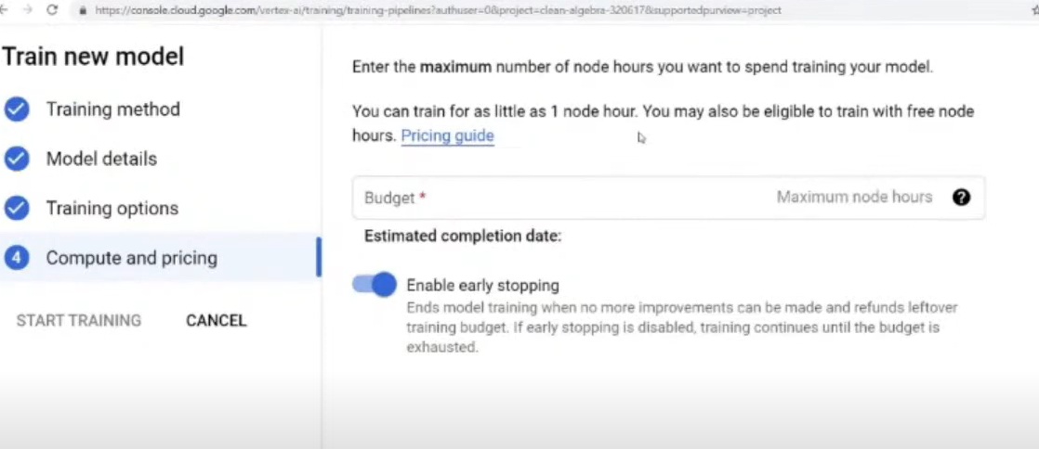

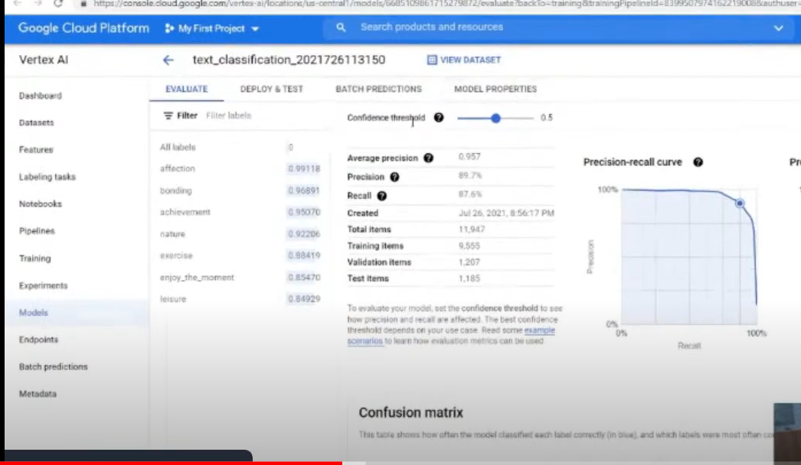

Feature importance:

Pixel importance

CUSTOM ML:

Notebooks;

All libraries preinstalled

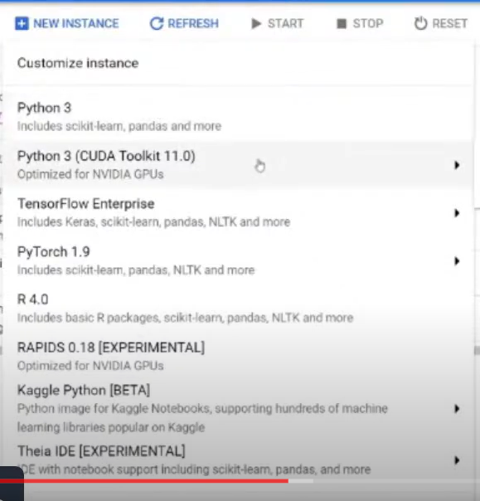

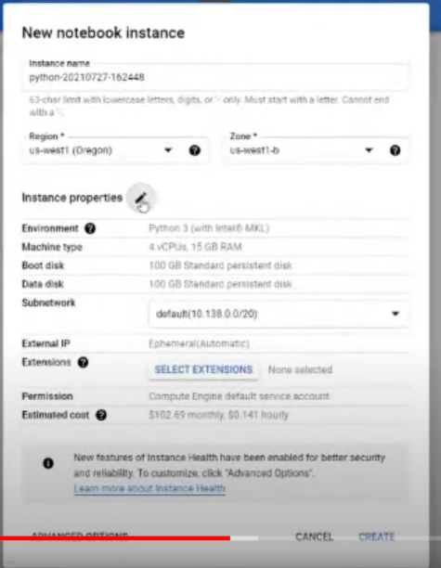

ENVIRONMENT SET UP

Project ID

Should be used it connects project with notebook

Storage bucket

Bucket for output

Import vertex SDK libraried

Hardware accelerators

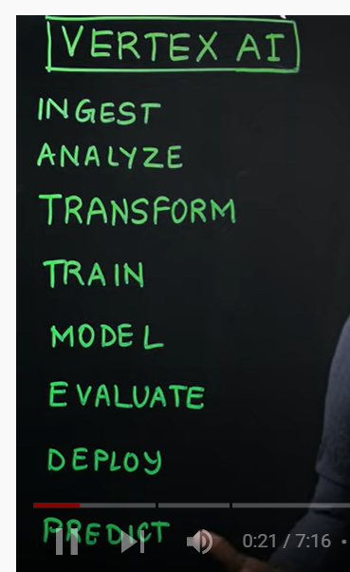

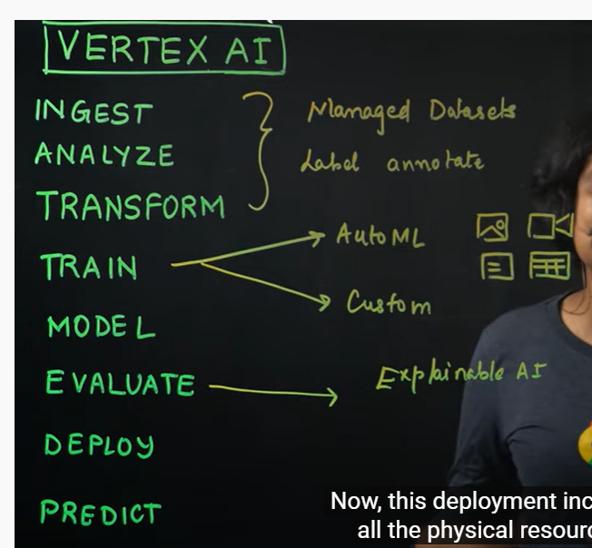

Vertex ai dash board

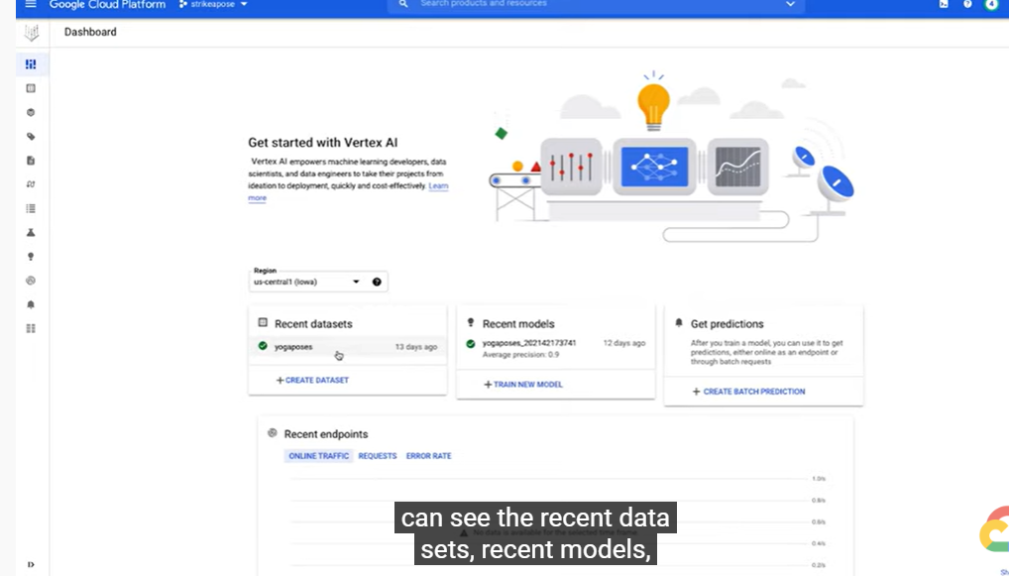

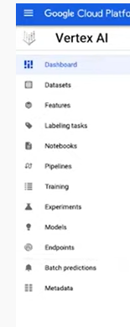

Datasets

Goto dataset -new dataset(CREATE BUTTON)

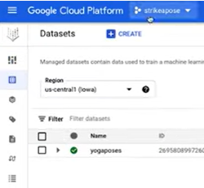

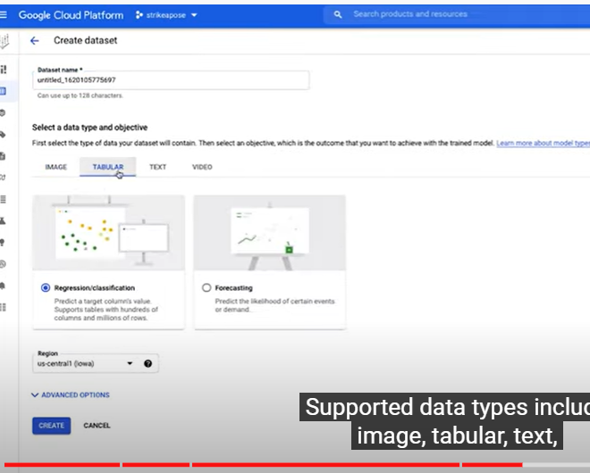

Once u create or upload dataset, we can see in datasets

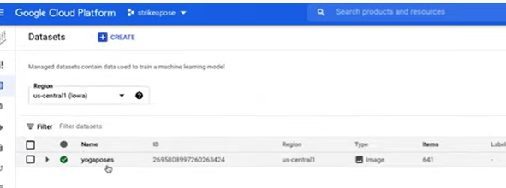

Now note book session

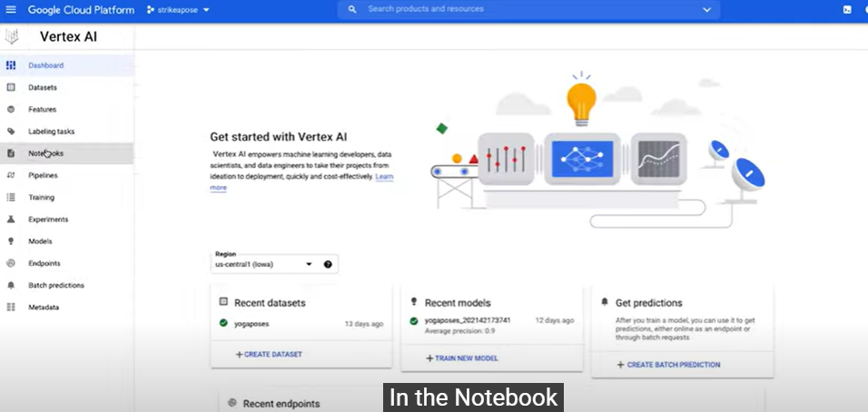

Click on create

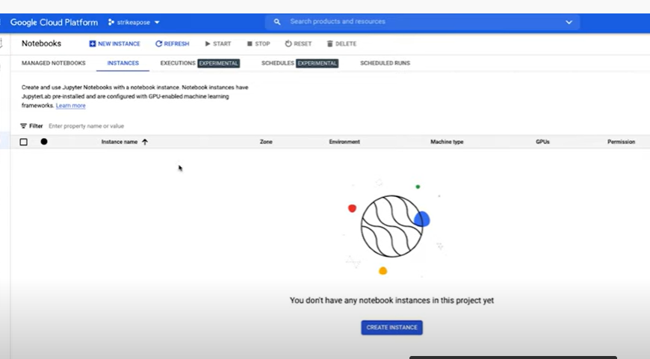

Configure

Type of envt

Name of notebook

Gpu

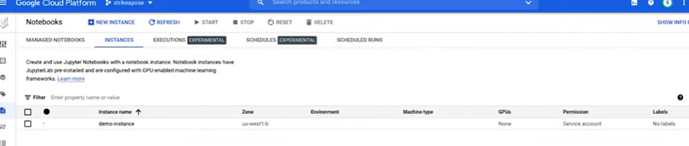

Open instance

This window will come

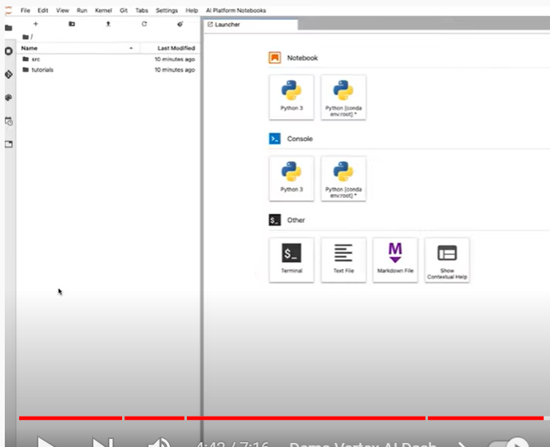

Now go to training tab

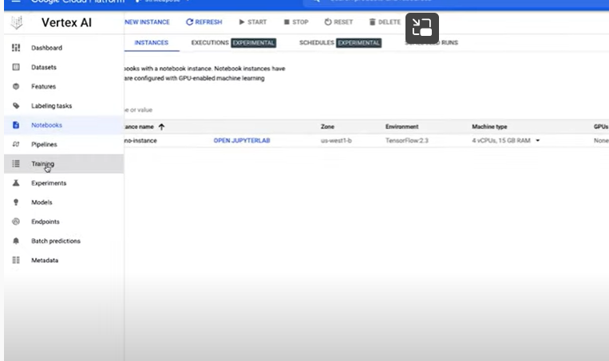

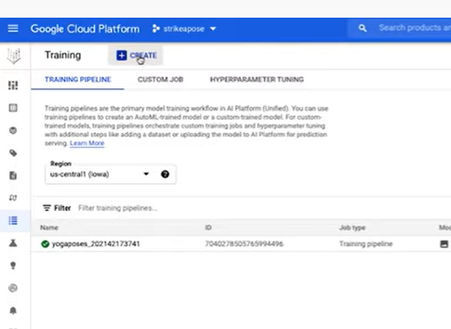

When u click on create

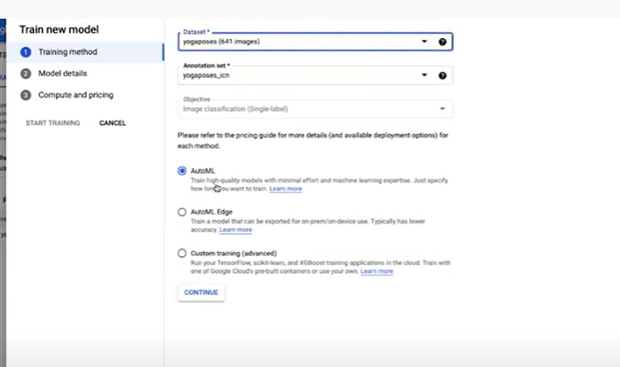

Custom training

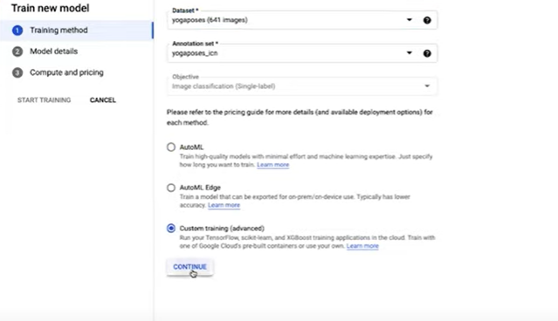

Click on continue

Again continue

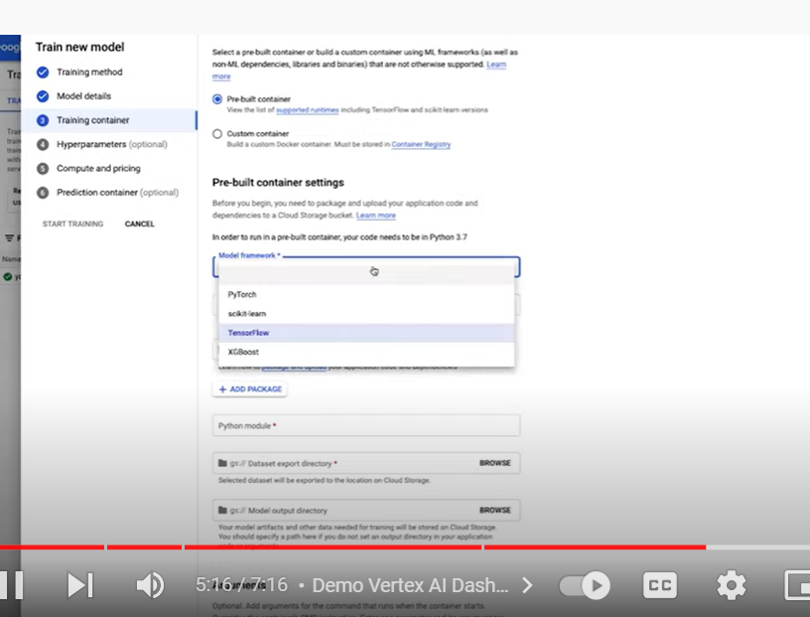

We will have pre built of custom container

In pre built:

In free built container it has supported frameworks like

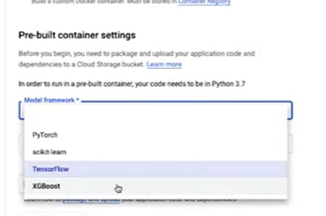

We provide our code as python package

In custom container

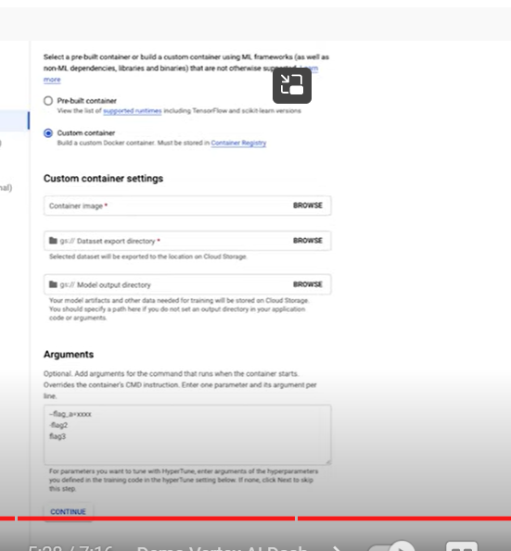

Any framework or language

Training code in docker container

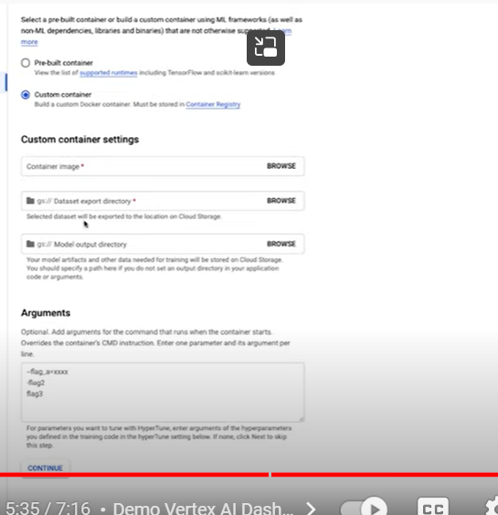

Now go to models tab

We can see all model we have created

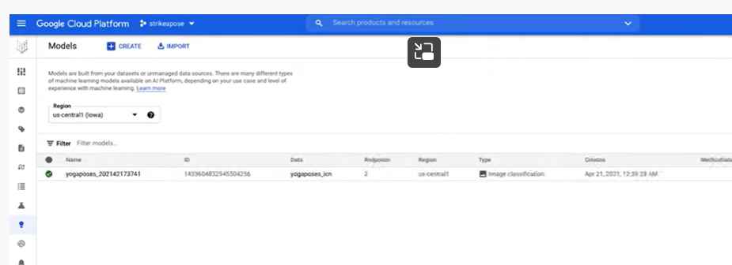

We can also import models created outside of gcp

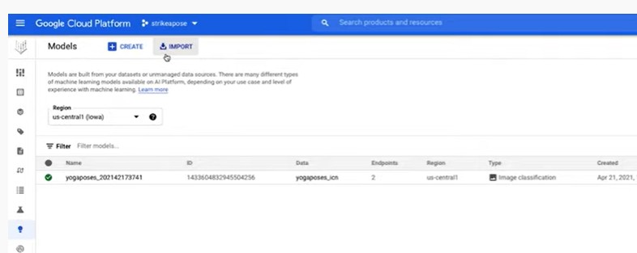

For to serve online or batch prediction

In order to use model we create endpoints

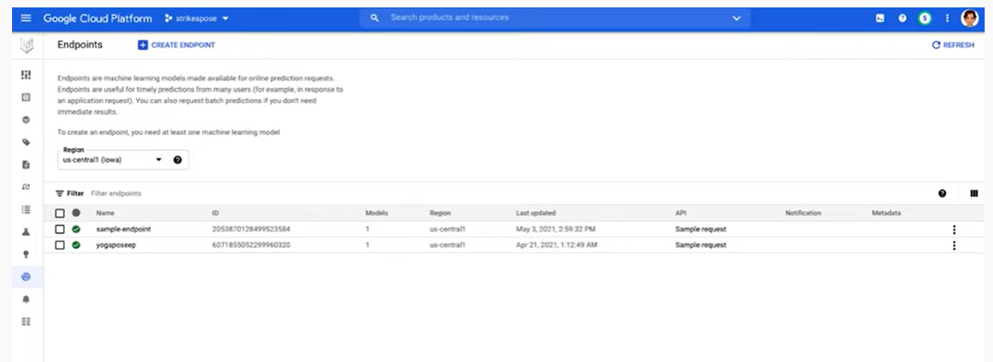

One model can have n number of endpoints

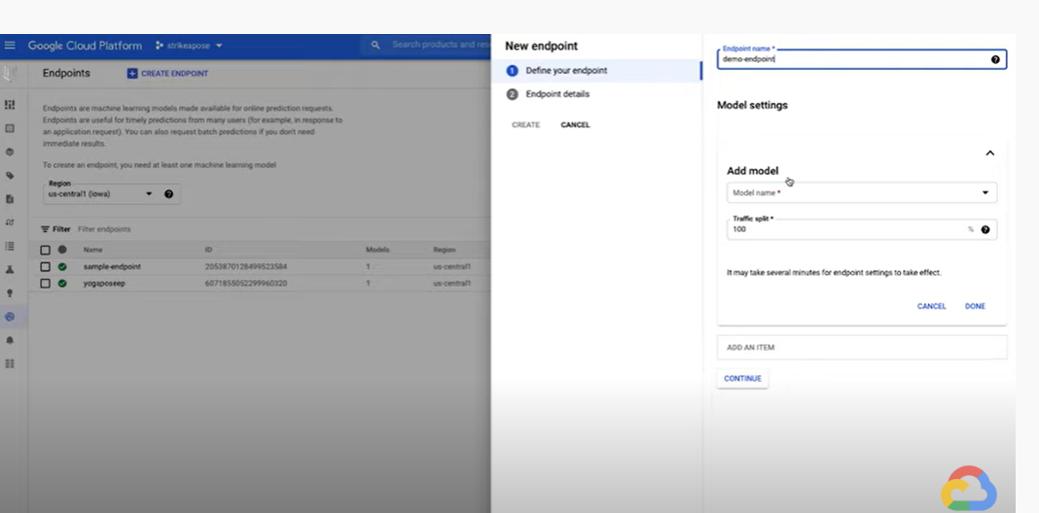

Once model is live we can predict either by UI or through SDK

Now go to model tab again

Click on the model

Upload new data for prediction

In model- in batch prediction tab

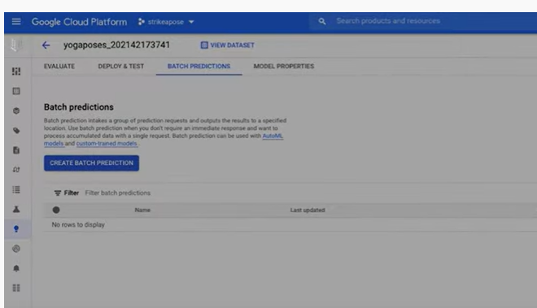

We can upload batch of data for prediction

**How to manage ML datasets with Vertex AI**

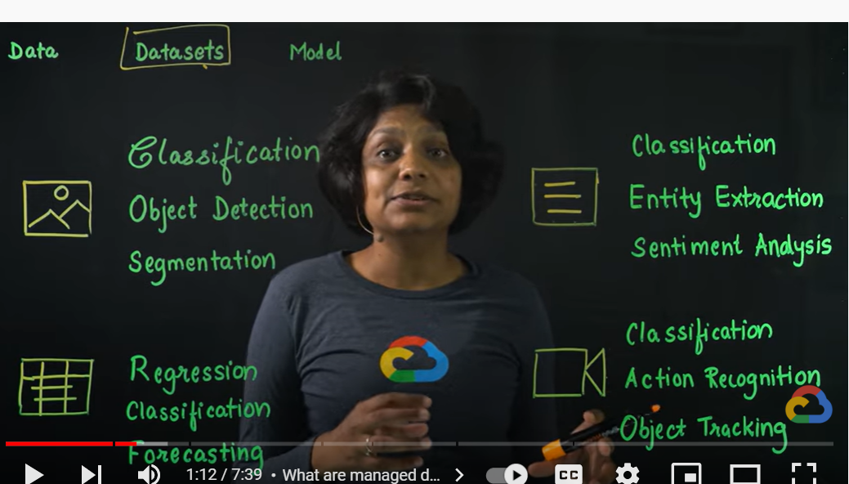

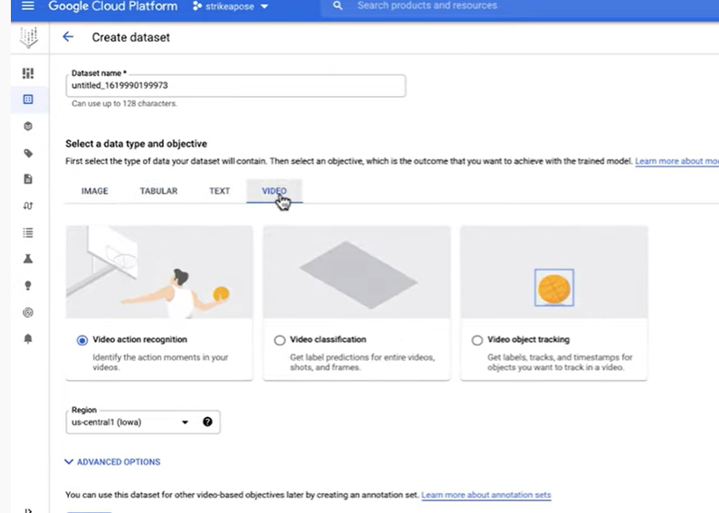

For example if we want to image classification

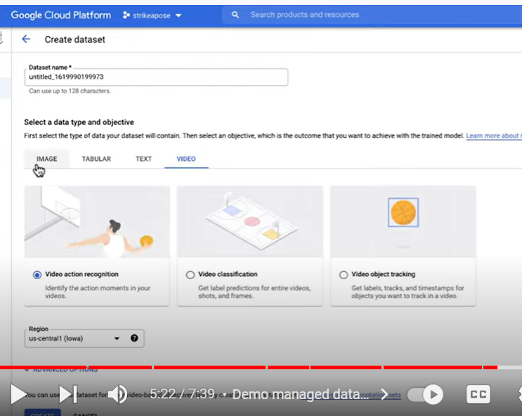

Check data guide for more details

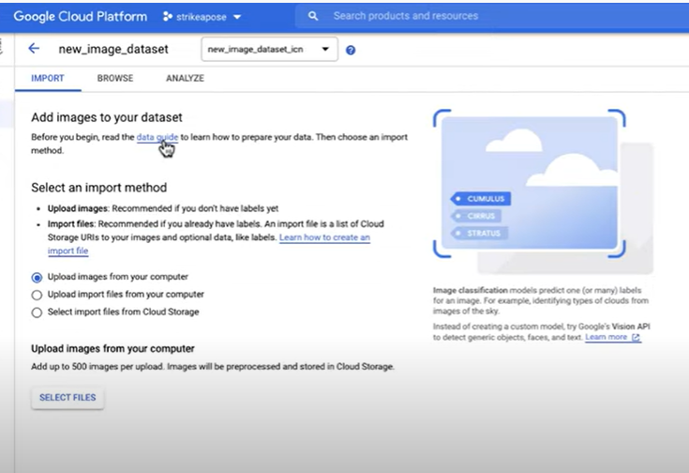

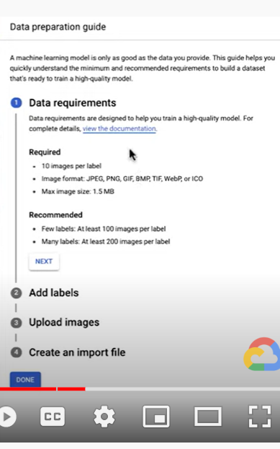

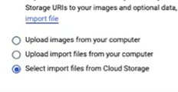

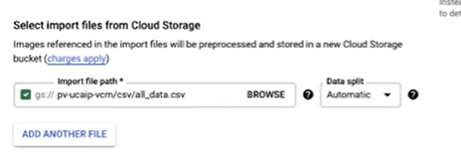

Now label images

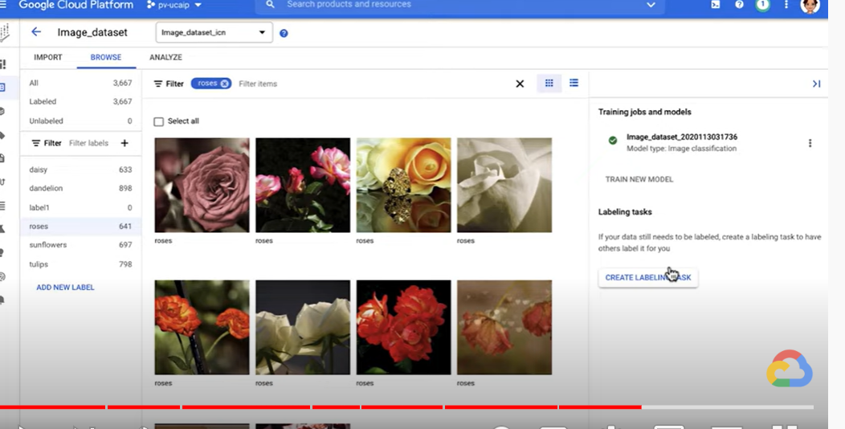

Human help to labeling

**Building and training ML models with Vertex AI**

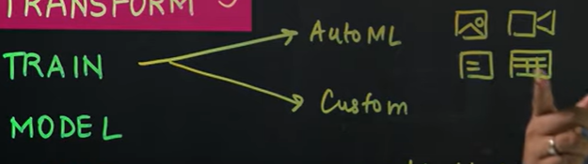

Building and training

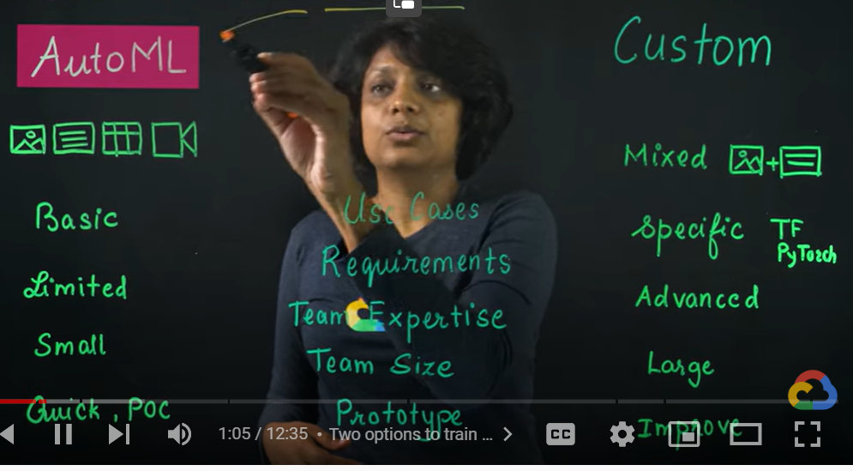

Data set

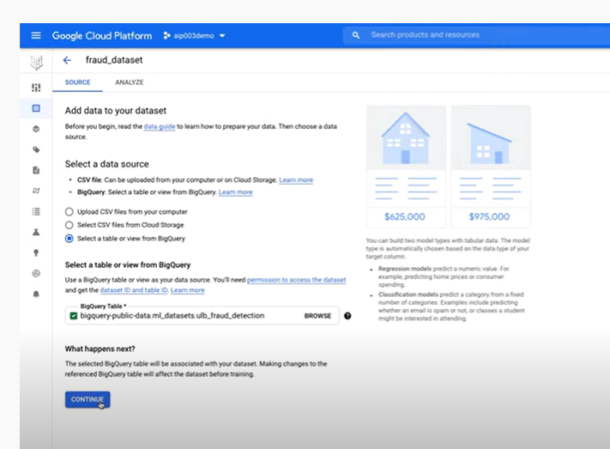

Dataset analyze page we can select train new model

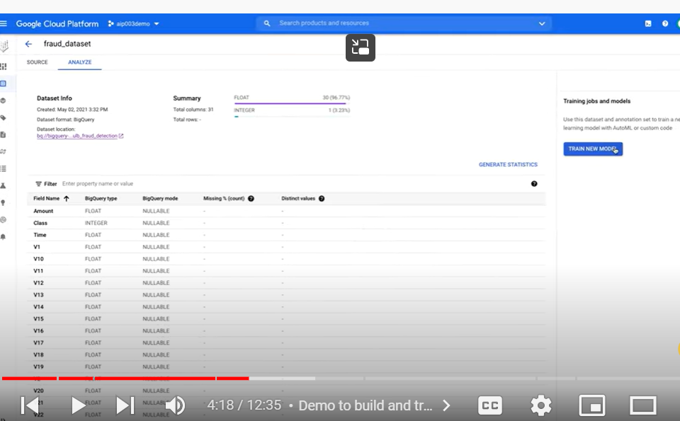

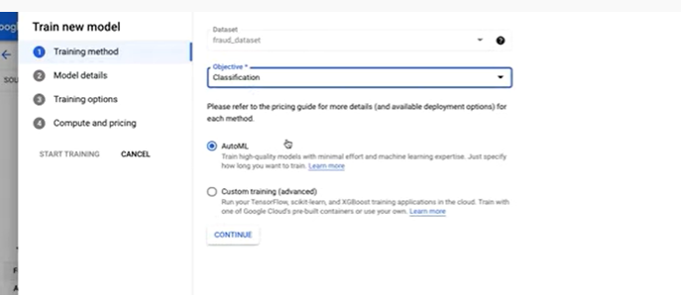

Auto ML

Continue

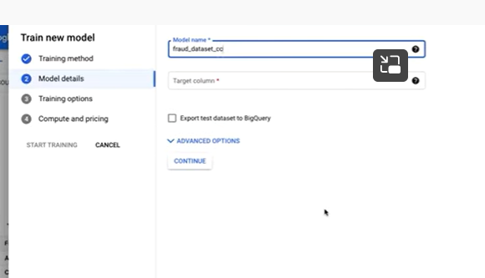

Give model name

Select target column

In advanced option we can select specific train test split

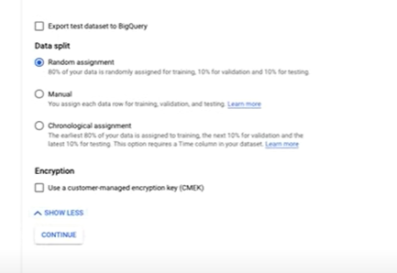

Random means vertex ai will do

Manual means we will give split of train and test data

Chronological means we give percentage of train and test split

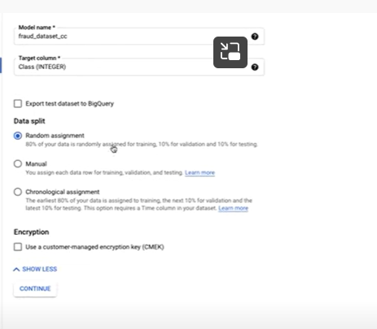

Training option

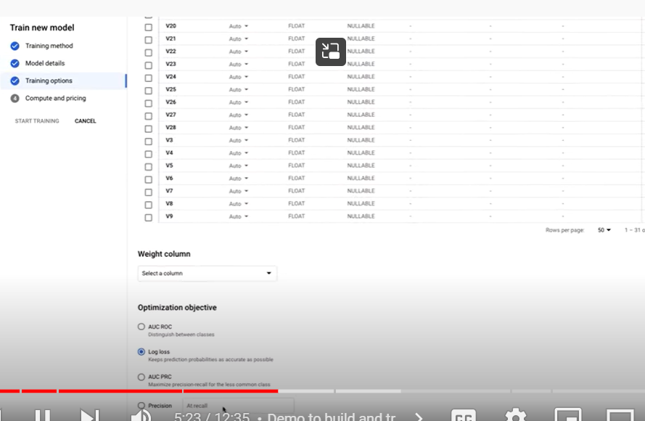

We choose auc -prc : imbalanced data set – which maximize precision and recall for less common class

Last step

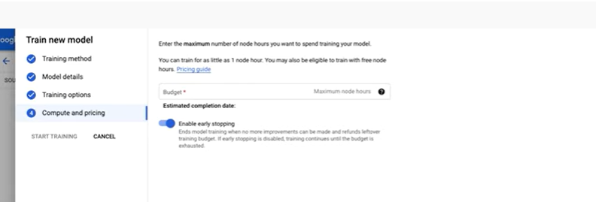

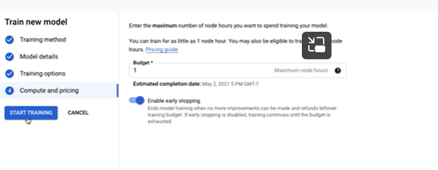

Start training

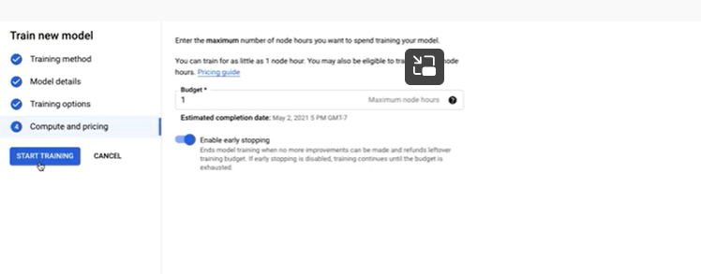

We get email when training job completes

Model is ready

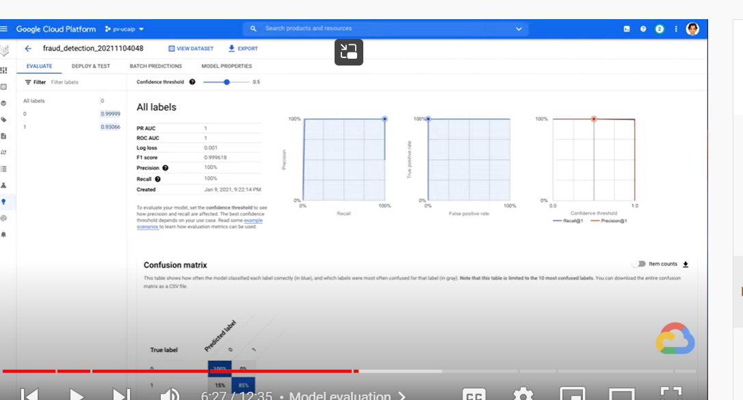

Explore model evaluation matrix

Now model is ready

Now create endpoint in vertex ai for batch prediction

In model – page

Deploy and test

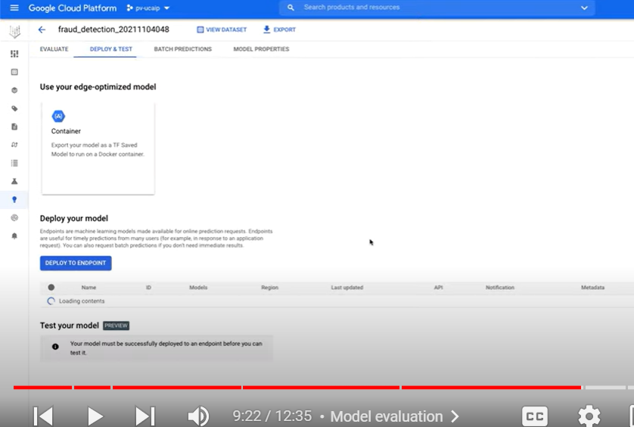

Click on deploy to endpoint

Give endpoint name

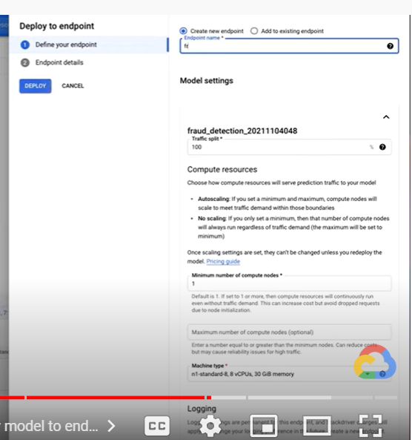

Machine type to deploy

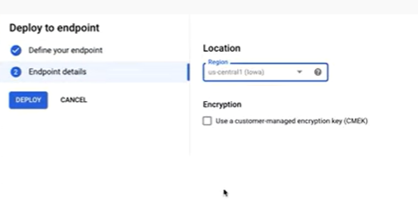

Leave location as it is

We can check batch prediction both by ui and sdk

In deploy and test –

After end point- go to test your model

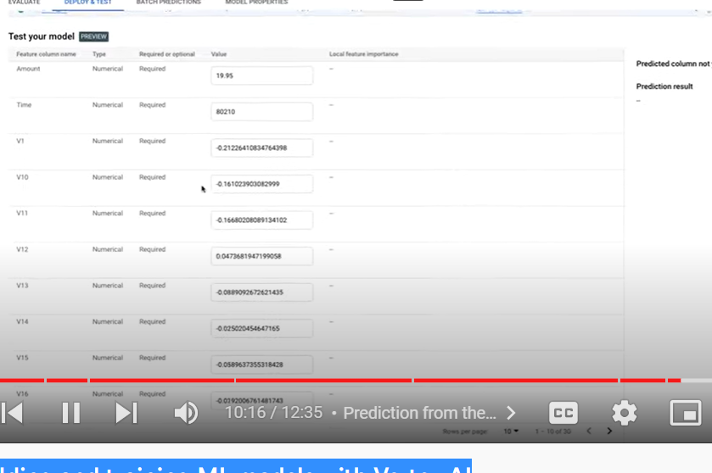

Select predict

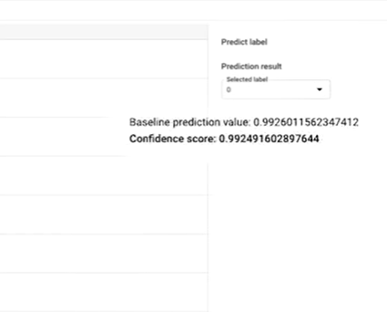

Ui canhelp us to know our model deployed perfectly

In order to predict dynamically – through api

We need to create note book

Go to note book

Create note book instance-

Select python version

Pip install vertex ai sdk

Add test cell

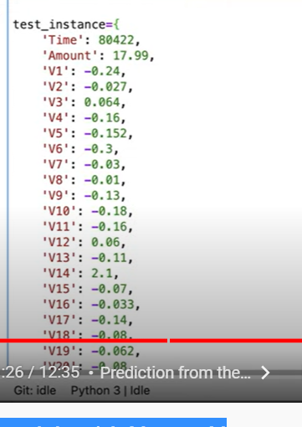

Then create instance

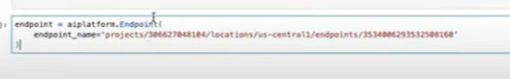

Change project id and endpoint id of our project

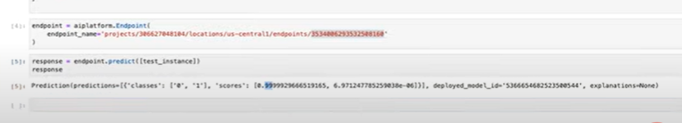

**Build a custom ML model with Vertex AI**

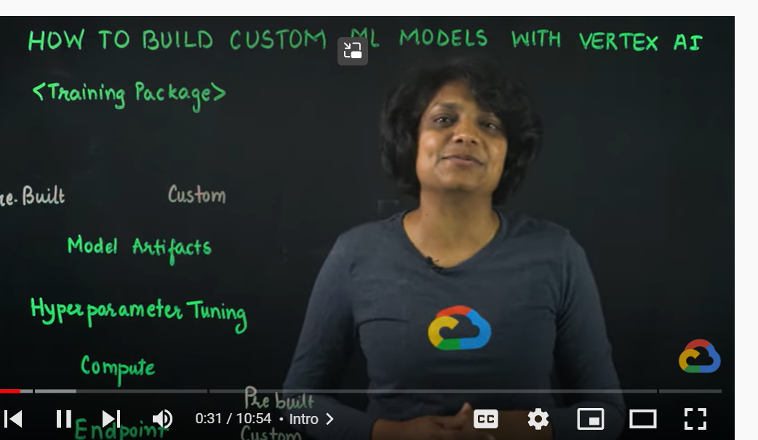

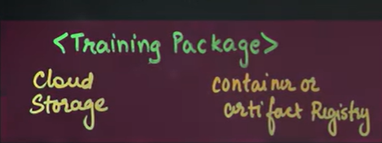

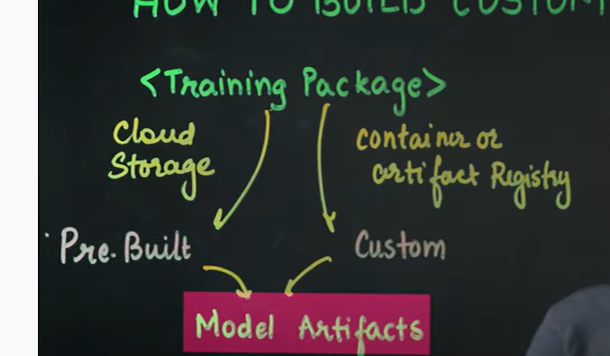

In both cases we need folder in cloud storage bucket to keep model artifacts

In custom training we can use vertex ai hyper parameter tuning services

To run training we need computer, for this we need to select computer instance with configurations’

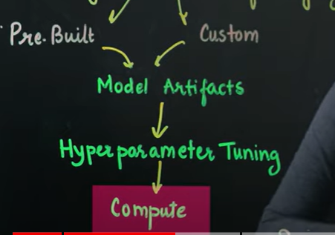

Once training done we need to create endpoint creation

We can use pre built container or custom container

Custom

we wil package our training code in docker container

first we create API

google cloud – select API and services

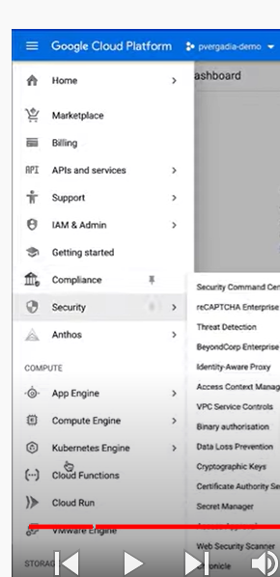

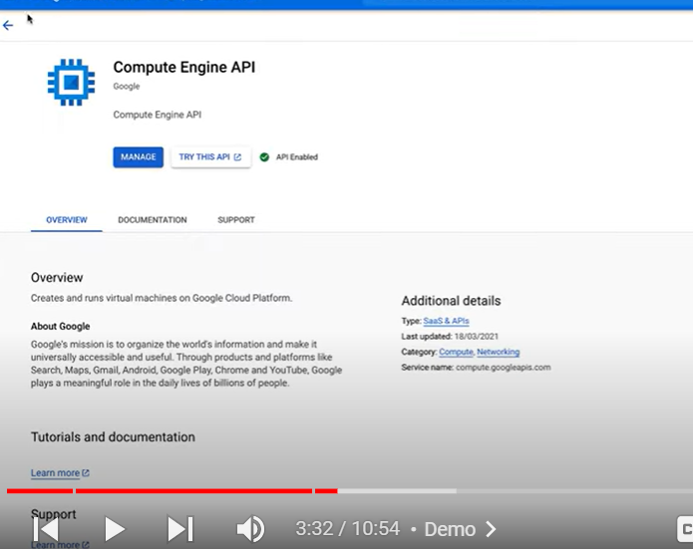

Computer engine api and container registry api

Now create new notebook instance

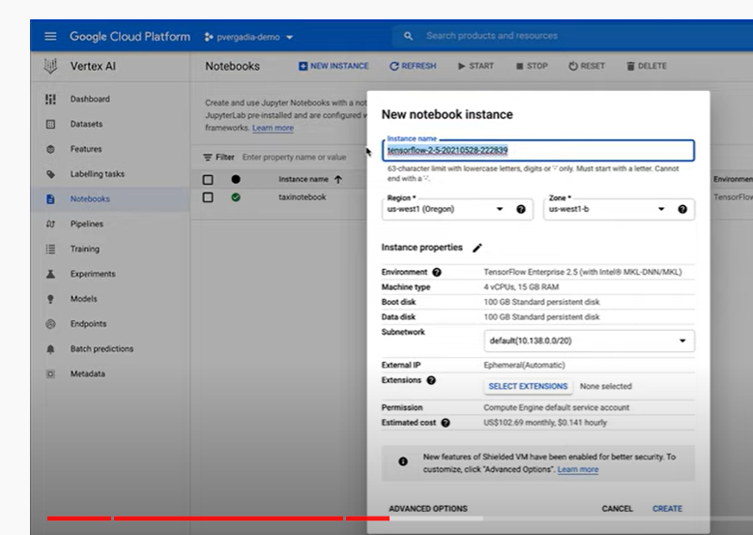

Open notebook instance

Navigate to terminal window

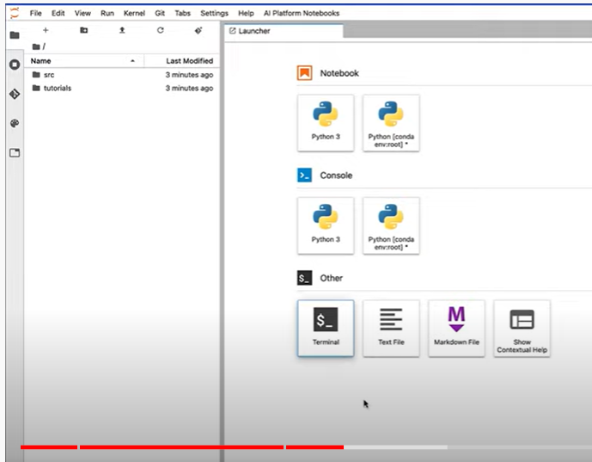

First step is to create docker file

Keep code in docker container and pushing this docker container to artifacts registry

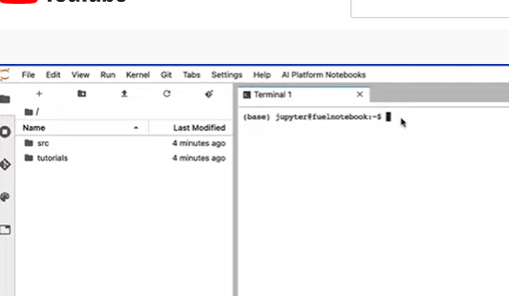

First step to create docker file

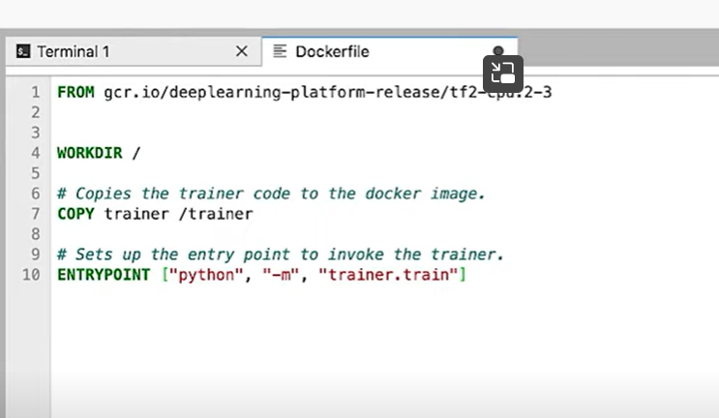

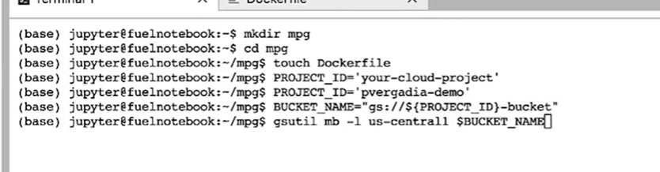

Cloud storage bucket should be created

Vertex ai use this bucket

Now to add code

Use trainer directory

Train.py file

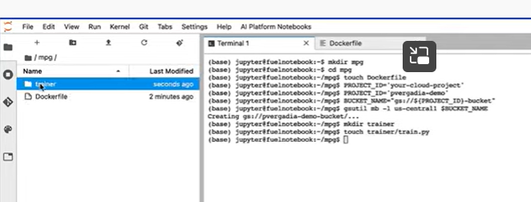

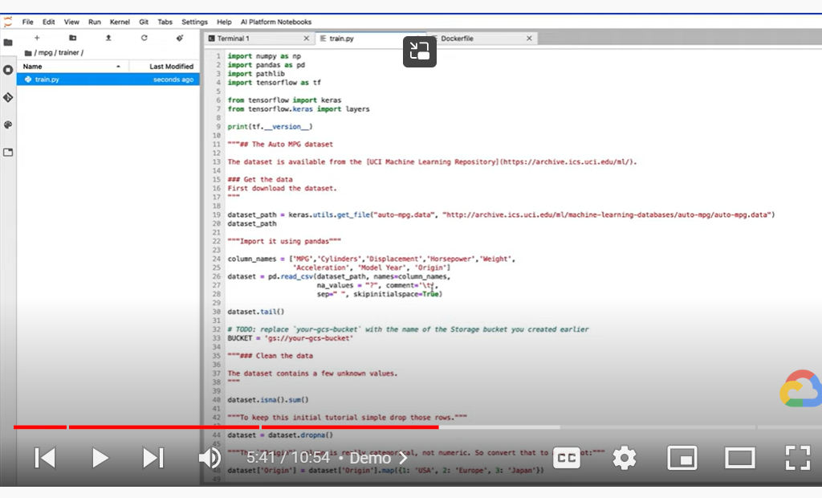

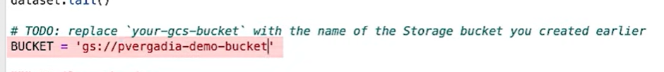

We need o update the bucket variable with name of bucket

Now we need to build and test the container locally

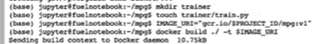

In production environment training takes much time

So u need to send this docker container to artifacts registry

Once sent to google cloud registry

Custom model

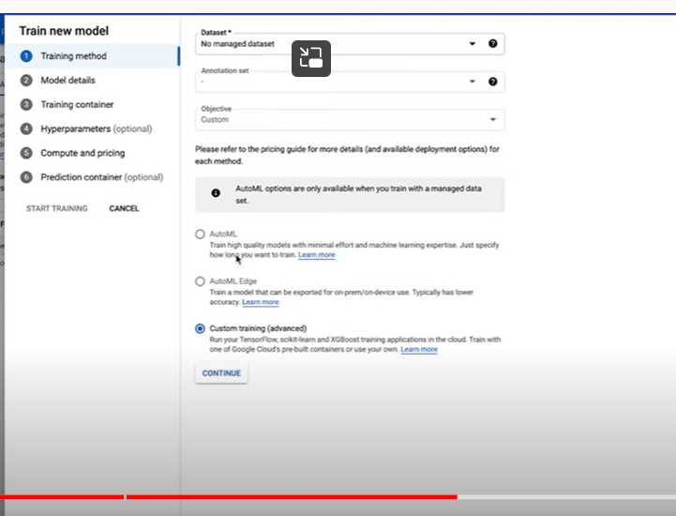

Training –

Select no managed dataset

Customs training

--Prebuilt and

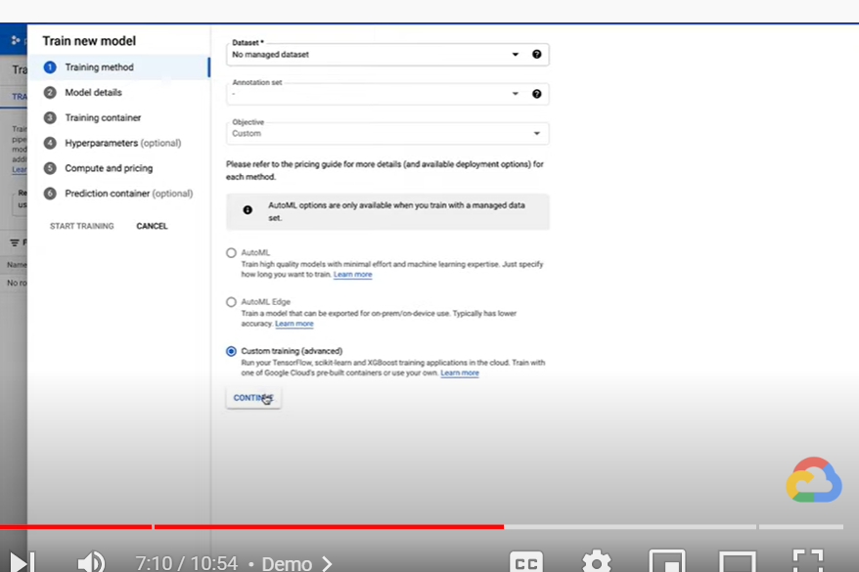

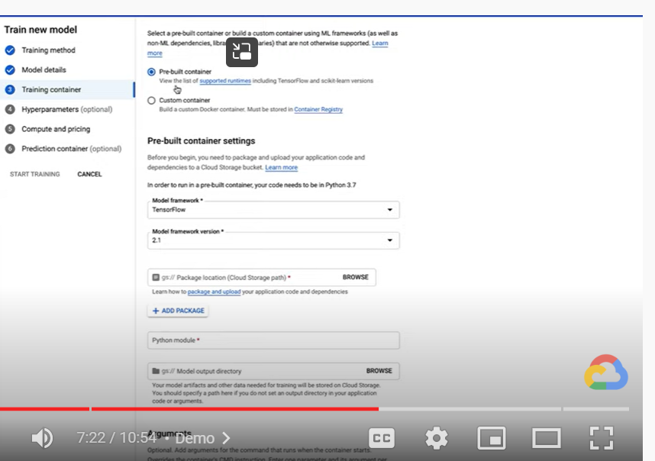

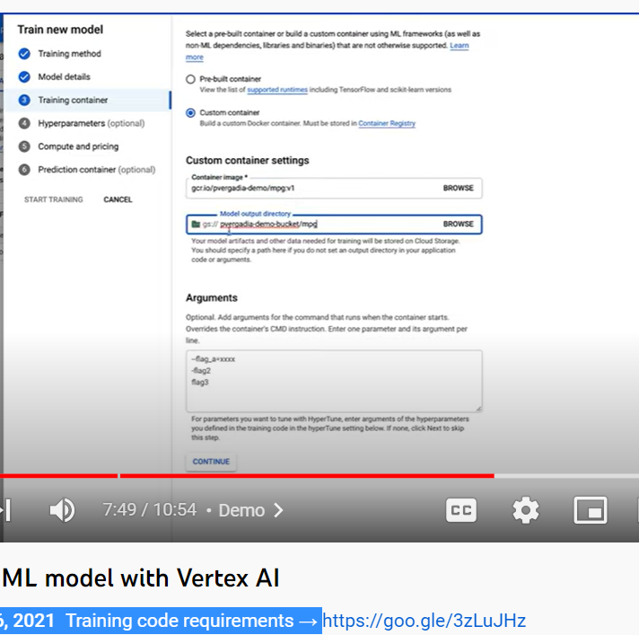

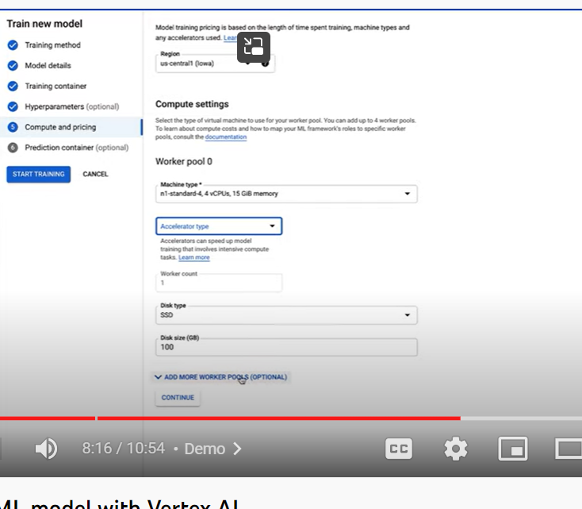

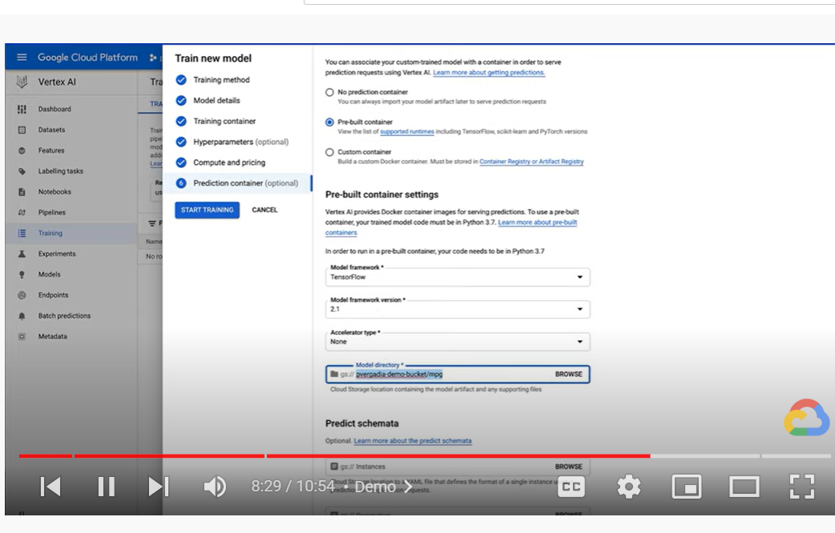

Click model

And create end points

‘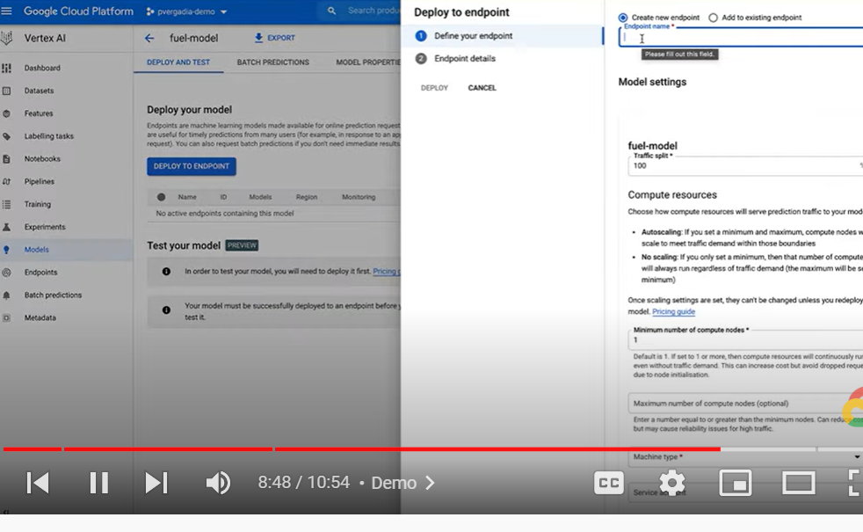

We get predictions in python note book- using python sdk

In note book

Install skd

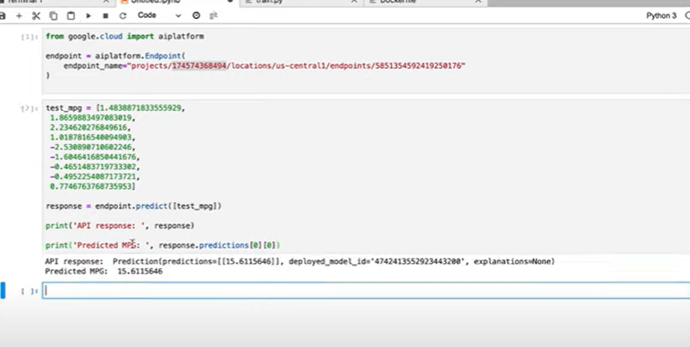

**Introduction to Vertex AI SDK**

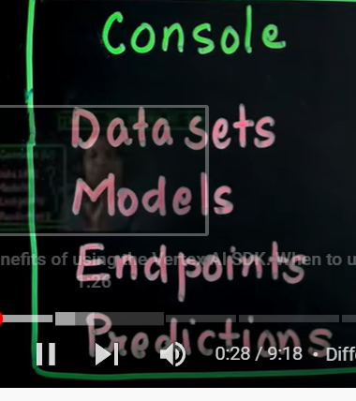

Anything we can do through ui/ console can also do programmatically

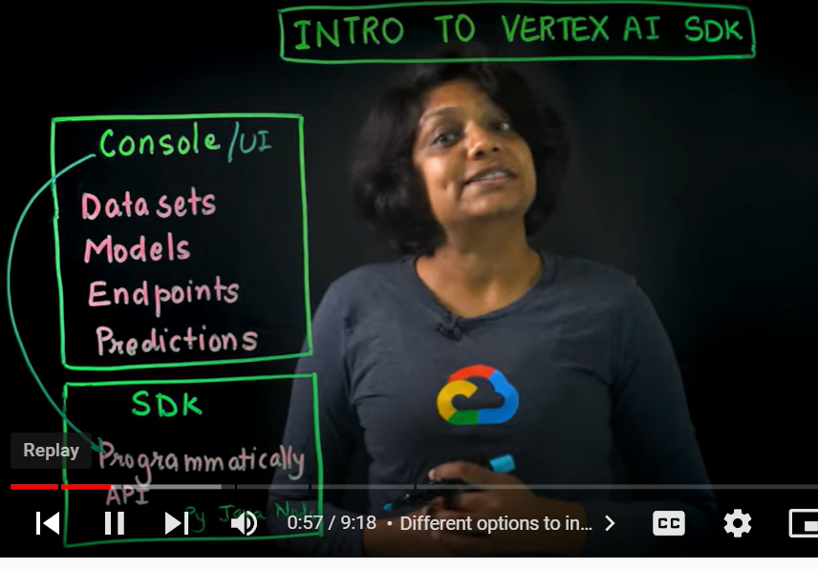

We can use client library

When to use console

When to use sdk- programmatically

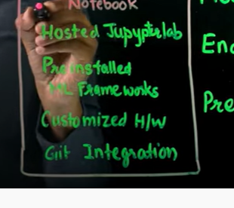

Put data – big query

Download data from big query

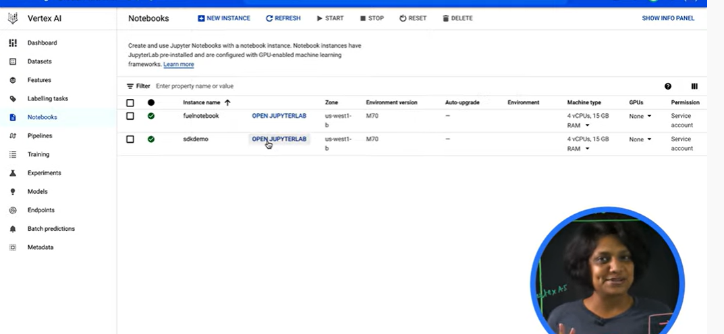

Create note book as per requirements

Import dataset in notebook

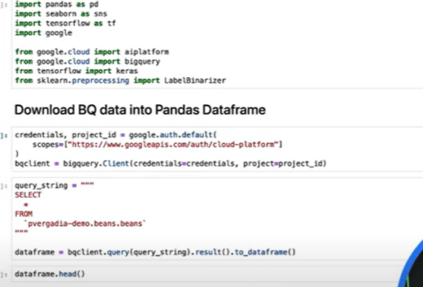

After exploratory analysis



